MY SQL QUERIES
COFFEE SHOP SALES PROJECT
CONVERT DATE (transaction_date) COLUMN TO PROPER DATE FORMAT
UPDATE coffee_shop_sales
SET transaction_date = STR_TO_DATE(transaction_date, '%d-%m-%Y');

ALTER DATE (transaction_date) COLUMN TO DATE DATA TYPE
ALTER TABLE coffee_shop_sales
MODIFY COLUMN transaction_date DATE;

CONVERT TIME (transaction_time) COLUMN TO PROPER DATE FORMAT
UPDATE coffee_shop_sales
SET transaction_time = STR_TO_DATE(transaction_time, '%H:%:%s');

ALTER TIME (transaction_time) COLUMN TO DATE DATA TYPE
ALTER TABLE coffee_shop_sales
MODIFY COLUMN transaction_time TIME;

DATA TYPES OF DIFFERENT COLUMNS
DESCRIBE coffee_shop_sales;
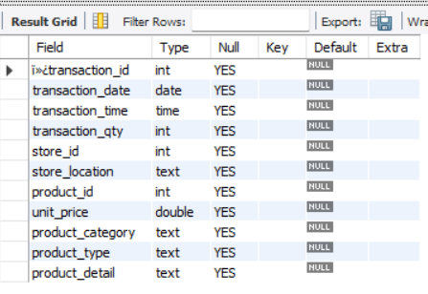

CHANGE COLUMN NAME `ï»¿transaction_id` to transaction_id
ALTER TABLE coffee_shop_sales
CHANGE COLUMN `ï»¿transaction_id` transaction_id INT;

TOTAL SALES
SELECT ROUND(SUM(unit_price * transaction_qty)) as Total_Sales
FROM coffee_shop_sales
WHERE MONTH(transaction_date) = 5 -- for month of (CM-May)
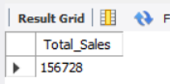

TOTAL SALES KPI - MOM DIFFERENCE AND MOM GROWTH
SELECT
MONTH(transaction_date) AS month,
ROUND(SUM(unit_price * transaction_qty)) AS total_sales,
(SUM(unit_price * transaction_qty) - LAG(SUM(unit_price * transaction_qty), 1)
OVER (ORDER BY MONTH(transaction_date))) / LAG(SUM(unit_price * transaction_qty), 1)
OVER (ORDER BY MONTH(transaction_date)) * 100 AS mom_increase_percentage
FROM
coffee_shop_sales
WHERE
MONTH(transaction_date) IN (4, 5) -- for months of April and May
GROUP BY
MONTH(transaction_date)
ORDER BY
MONTH(transaction_date);
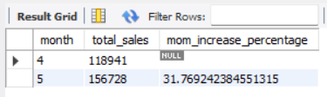
TOTAL ORDERS
SELECT COUNT(transaction_id) as Total_Orders
FROM coffee_shop_sales
WHERE MONTH (transaction_date)= 5 -- for month of (CM-May)
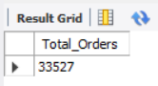

TOTAL ORDERS KPI - MOM DIFFERENCE AND MOM GROWTH
SELECT
MONTH(transaction_date) AS month,
ROUND(COUNT(transaction_id)) AS total_orders,
(COUNT(transaction_id) - LAG(COUNT(transaction_id), 1)
OVER (ORDER BY MONTH(transaction_date))) / LAG(COUNT(transaction_id), 1)
OVER (ORDER BY MONTH(transaction_date)) * 100 AS mom_increase_percentage
FROM
coffee_shop_sales
WHERE
MONTH(transaction_date) IN (4, 5) -- for April and May
GROUP BY
MONTH(transaction_date)
ORDER BY
MONTH(transaction_date);

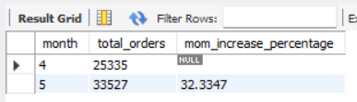

TOTAL QUANTITY SOLD
SELECT SUM(transaction_qty) as Total_Quantity_Sold
FROM coffee_shop_sales
WHERE MONTH(transaction_date) = 5 -- for month of (CM-May)
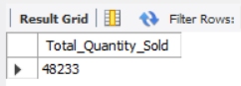

TOTAL QUANTITY SOLD KPI - MOM DIFFERENCE AND MOM GROWTH
SELECT
MONTH(transaction_date) AS month,
ROUND(SUM(transaction_qty)) AS total_quantity_sold,
(SUM(transaction_qty) - LAG(SUM(transaction_qty), 1)
OVER (ORDER BY MONTH(transaction_date))) / LAG(SUM(transaction_qty), 1)
OVER (ORDER BY MONTH(transaction_date)) * 100 AS mom_increase_percentage
FROM
coffee_shop_sales
WHERE
MONTH(transaction_date) IN (4, 5) -- for April and May
GROUP BY
MONTH(transaction_date)
ORDER BY
MONTH(transaction_date);

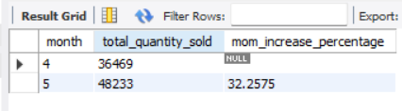

CALENDAR TABLE – DAILY SALES, QUANTITY and TOTAL ORDERS
SELECT
SUM(unit_price * transaction_qty) AS total_sales,
SUM(transaction_qty) AS total_quantity_sold,
COUNT(transaction_id) AS total_orders
FROM
coffee_shop_sales
WHERE
transaction_date = '2023-05-18'; --For 18 May 2023
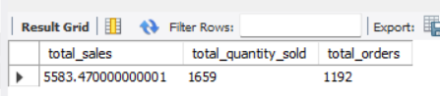

b/c we want to get exact Rounded off values so, we use below query to get the result:
SELECT
CONCAT(ROUND(SUM(unit_price * transaction_qty) / 1000, 1),'K') AS total_sales,
CONCAT(ROUND(COUNT(transaction_id) / 1000, 1),'K') AS total_orders,
CONCAT(ROUND(SUM(transaction_qty) / 1000, 1),'K') AS total_quantity_sold
FROM
coffee_shop_sales
WHERE
transaction_date = '2023-05-18'; --For 18 May 2023
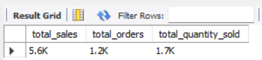

SALES TREND OVER PERIOD
SELECT AVG(total_sales) AS average_sales
FROM (
SELECT
SUM(unit_price * transaction_qty) AS total_sales
FROM
coffee_shop_sales
WHERE
MONTH(transaction_date) = 5 -- Filter for May
GROUP BY
transaction_date
) AS internal_query;
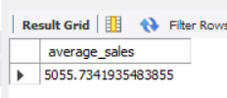

DAILY SALES FOR MONTH SELECTED
SELECT
DAY(transaction_date) AS day_of_month,
ROUND(SUM(unit_price * transaction_qty),1) AS total_sales
FROM
coffee_shop_sales
WHERE
MONTH(transaction_date) = 5 -- Filter for May
GROUP BY
DAY(transaction_date)
ORDER BY
DAY(transaction_date);

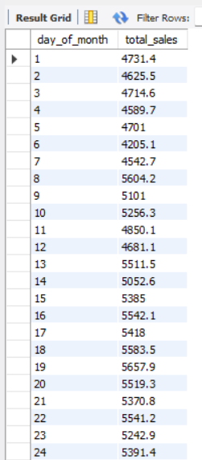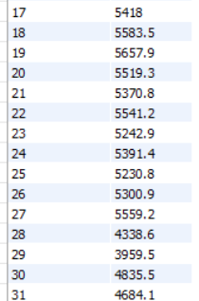

COMPARING DAILY SALES WITH AVERAGE SALES – IF GREATER THAN “ABOVE AVERAGE” and LESSER THAN “BELOW AVERAGE”
SELECT
day_of_month,
CASE
WHEN total_sales > avg_sales THEN 'Above Average'
WHEN total_sales < avg_sales THEN 'Below Average'
ELSE 'Average'
END AS sales_status,
total_sales
FROM (
SELECT
DAY(transaction_date) AS day_of_month,
SUM(unit_price * transaction_qty) AS total_sales,
AVG(SUM(unit_price * transaction_qty)) OVER () AS avg_sales
FROM
coffee_shop_sales
WHERE
MONTH(transaction_date) = 5 -- Filter for May
GROUP BY
DAY(transaction_date)
) AS sales_data
ORDER BY
day_of_month;

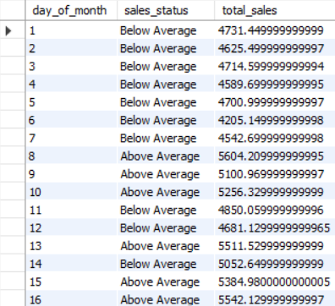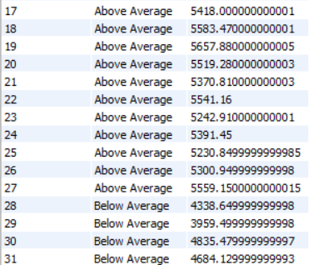

SALES BY WEEKDAY / WEEKEND:
SELECT
CASE
WHEN DAYOFWEEK(transaction_date) IN (1, 7) THEN 'Weekends'
ELSE 'Weekdays'
END AS day_type,
ROUND(SUM(unit_price * transaction_qty),2) AS total_sales
FROM
coffee_shop_sales
WHERE
MONTH(transaction_date) = 5 -- Filter for May
GROUP BY
CASE
WHEN DAYOFWEEK(transaction_date) IN (1, 7) THEN 'Weekends'
ELSE 'Weekdays'
END;

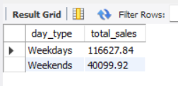

SALES BY STORE LOCATION
SELECT
store_location,
SUM(unit_price * transaction_qty) as Total_Sales
FROM coffee_shop_sales
WHERE
MONTH(transaction_date) =5
GROUP BY store_location
ORDER BY SUM(unit_price * transaction_qty) DESC

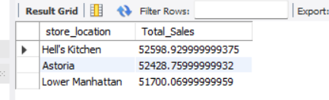

SALES BY PRODUCT CATEGORY
SELECT
product_category,
ROUND(SUM(unit_price * transaction_qty),1) as Total_Sales
FROM coffee_shop_sales
WHERE
MONTH(transaction_date) = 5
GROUP BY product_category
ORDER BY SUM(unit_price * transaction_qty) DESC
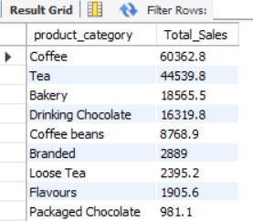

SALES BY PRODUCTS (TOP 10)
SELECT
product_type,
ROUND(SUM(unit_price * transaction_qty),1) as Total_Sales
FROM coffee_shop_sales
WHERE
MONTH(transaction_date) = 5
GROUP BY product_type
ORDER BY SUM(unit_price * transaction_qty) DESC
LIMIT 10

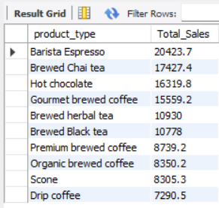

SALES BY DAY | HOUR
SELECT
ROUND(SUM(unit_price * transaction_qty)) AS Total_Sales,
SUM(transaction_qty) AS Total_Quantity,
COUNT(*) AS Total_Orders
FROM
coffee_shop_sales
WHERE
DAYOFWEEK(transaction_date) = 3 -- Filter for Tuesday (1 is Sunday, 2 is Monday, ..., 7 is Saturday)
AND HOUR(transaction_time) = 8 -- Filter for hour number 8
AND MONTH(transaction_date) = 5; -- Filter for May (month number 5)

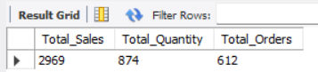

TO GET SALES FROM MONDAY TO SUNDAY FOR MONTH OF MAY
SELECT
CASE
WHEN DAYOFWEEK(transaction_date) = 2 THEN 'Monday'
WHEN DAYOFWEEK(transaction_date) = 3 THEN 'Tuesday'
WHEN DAYOFWEEK(transaction_date) = 4 THEN 'Wednesday'
WHEN DAYOFWEEK(transaction_date) = 5 THEN 'Thursday'
WHEN DAYOFWEEK(transaction_date) = 6 THEN 'Friday'
WHEN DAYOFWEEK(transaction_date) = 7 THEN 'Saturday'
ELSE 'Sunday'
END AS Day_of_Week,
ROUND(SUM(unit_price * transaction_qty)) AS Total_Sales
FROM
coffee_shop_sales
WHERE
MONTH(transaction_date) = 5 -- Filter for May (month number 5)
GROUP BY
CASE
WHEN DAYOFWEEK(transaction_date) = 2 THEN 'Monday'
WHEN DAYOFWEEK(transaction_date) = 3 THEN 'Tuesday'
WHEN DAYOFWEEK(transaction_date) = 4 THEN 'Wednesday'
WHEN DAYOFWEEK(transaction_date) = 5 THEN 'Thursday'
WHEN DAYOFWEEK(transaction_date) = 6 THEN 'Friday'
WHEN DAYOFWEEK(transaction_date) = 7 THEN 'Saturday'
ELSE 'Sunday'
END;

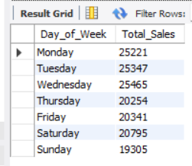

TO GET SALES FOR ALL HOURS FOR MONTH OF MAY
SELECT
HOUR(transaction_time) AS Hour_of_Day,
ROUND(SUM(unit_price * transaction_qty)) AS Total_Sales
FROM
coffee_shop_sales
WHERE
MONTH(transaction_date) = 5 -- Filter for May (month number 5)
GROUP BY
HOUR(transaction_time)
ORDER BY
HOUR(transaction_time);

